Assignment 1 Report
Kelly Jones
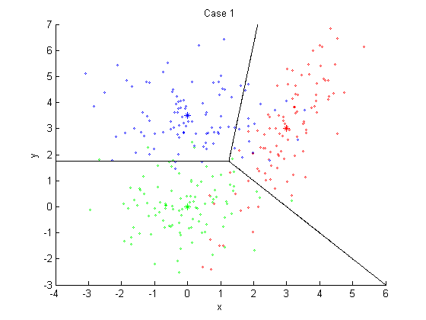

Error Train | Error Test
0.3533 | 0.3304

Case 1's error rate was the highest of the classifiers. ω2 has a distribution with greater density along an axis close to the vector between σ1 and σ2. Since this vector is an important part of the generation of discriminating functions, a classification made with case 1 will be inaccurate.

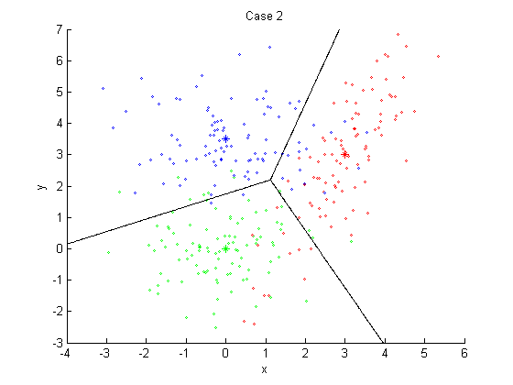
Train Error | Test Error
0.2333 | 0.2395

Case 2's error rate was better than case 1 but falls short of case 3. The diagonal axis that ω2 is distributed along is better handled by case 2.

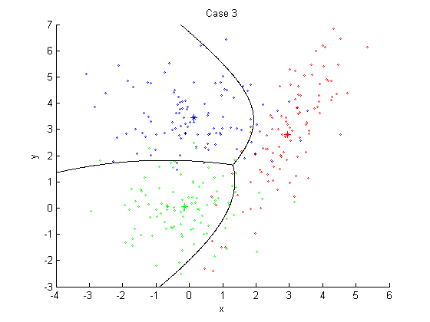
Train Error | Test Error
0.1433 | 0.1305

Case 3 has the best success with classification on classes with no common covariance so it follows that it would have the best performance on this data. Since decision curves and discriminant functions are trained with the unique covariance belonging to the classes, classification is more accurate.

